Westlake Village, California, September 20th, 2022 — ISSQUARED®, (www.issquaredinc.com) one of the fastest growing cyber security, cloud infrastructure companies announces the launch of FABULIX, the answer to autonomous infrastructure at GITEX GLOBAL October 10-14 at the Dubai World Trade Center.
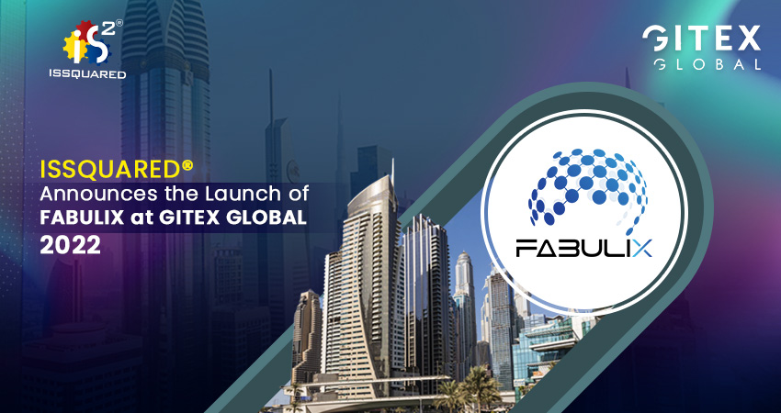
FABULIX transforms your infrastructure with state-of-the art computing, networking, and virtualization all in one seamless system. This hyperconverged infrastructure platform combines compute, storage, network and virtualization resources in a single easy-to-use system. Built on Microsoft Windows Server 2019, FABULIX provides a very cost-effective solution for small and medium size enterprises to meet their most demanding workloads.
With different architectures to choose from, FABULIX simplifies your demanding workloads in a sustainable cost-controlled way whether your infrastructure is on premise, hybrid, or in the cloud. The FABULIX advantage provides a pre-built solution, customizable to manage your existing virtualized workloads and gain cloud efficiencies on premise.
For more see Fabulix - Manage Your IT With Simplicity, Security, Flexibility and Efficiency or come by the ISSQUARED® booth.

About ISSQUARED®
ISSQUARED® is a leading provider of Cyber Security, Identity Management, Cloud/ Edge Infrastructure products, Consulting, and Digital Transformation services. In addition to an extensive set of digital transformation solutions, ISSQUARED® offers a comprehensive portfolio of software products to address operational excellence and solve the most pressing security and governance needs. For many years, ISSQUARED® has been helping several Fortune 500 organizations and delivered several multi-million-dollar projects. Our proven expertise takes our clients through a seamless digital and security transformation, resulting in rapid business benefits and positioning them for future success. ISSQUARED® is headquartered in Westlake Village, California, the US with a Cyber Technology Center based in Chardon, Ohio. It offers global delivery capabilities with its presence across the Middle East, India, and other parts of the US too. For more information visit www.issquaredinc.com or follow us on Facebook, LinkedIn, and Twitter.

About GITEX Global
GITEX Global, the annual tech event, features global technology players and covers the latest trends & innovations from diverse sectors. The event aims to empower your business and connect you to the most influential public-private partnerships, tech giants, creative startups, and enterprises from over 170 countries. GITEX Global hosts thought-leaders, creators, innovators, and makers from various technology verticals to come together and discuss debate & challenge new ideologies.

