Akuvox & akubela at GITEX GLOBAL 2022: Transport Audience to the Smarter Living and Access!

Akuvox, the global leading provider of smart AIoT products and solutions, together with its newly launched smart home brand akubela, is heading to GITEX GLOBAL 2022, the world's largest tech and startup super-connector event. This event will take place in Dubai, the United Arab Emirates from Oct 10 to Oct 14, 2022.

Akuvox strives to unleash the power of technologies to improve people's lives with better communication, greater security, and more convenience. The GITEX GLOBAL 2022 will be a great opportunity to explore Akuvox smart intercom and akubela smart home.

What you can expect from Akuvox and akubela at GITEX GLOBAL 2022?

Encompassing artificial intelligence, SIP, Android, cloud, security, and other advanced technologies, Akuvox smart intercom leverages vast fields of technologies for smart building access. Robust quality, stylish design, and cutting-edge access technology such as BLE and face recognition are blended in Akuvox smart intercom, which enables users to enjoy seamless entrance experiences with improved security and communication.
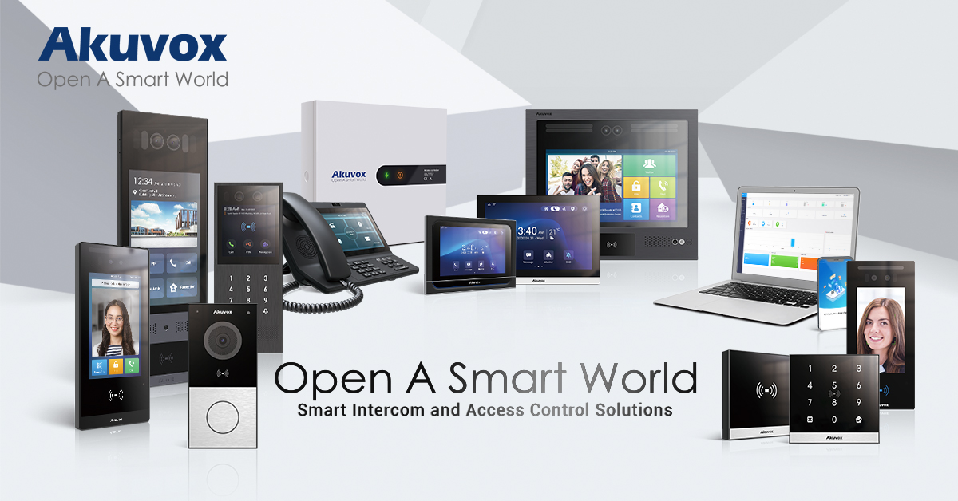

Akuvox smart intercom caters to not only modern building installation but also old building retrofitting. Upgrading to a smart intercom that supports audio and video communication often involves expensive, time-consuming rewiring for buildings. However, with the cost-effective Akuvox's 2-wire SIP video intercoms, installers can reuse the existing 2-wire cables to install Akuvox intercom devices. And the long data transmission distance of up to 300 meters between devices makes it possible to deploy the Akuvox system for large installs. Moreover, residents can enjoy the supreme audio and video communication experience provided by Akuvox smart intercom and open the door remotely for visitors on their mobile phones wherever they are, which improves property security and resident experience.
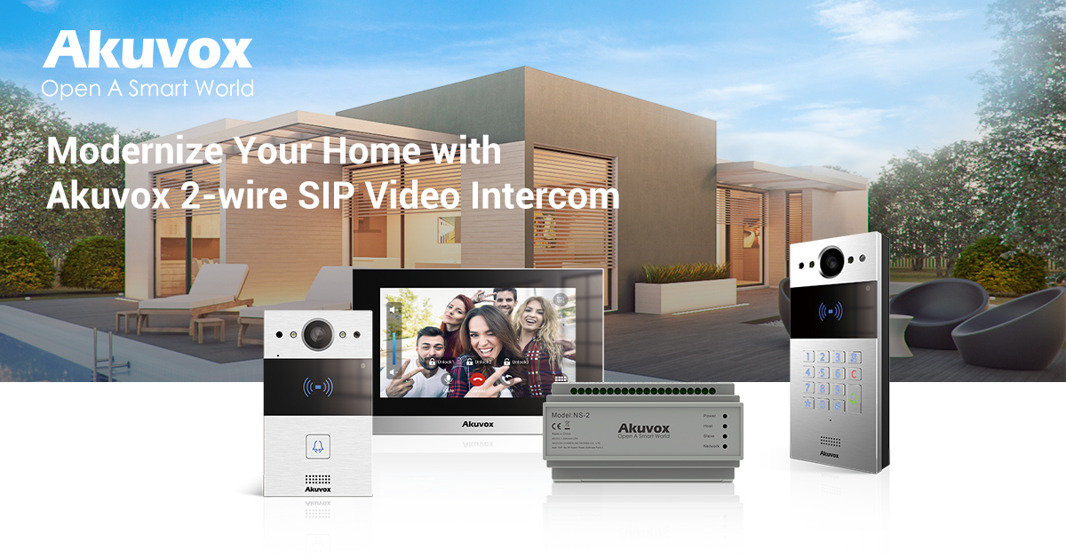

Now with the launch of akubela smart home, Akuvox proposes a whole-home intelligence solution that combines the application of the two systems. For one thing, with akubela, which conjoins disparate subsystems such as intercoms, security panels, gateways, dimmers, and sensors, residents are able to say goodbye to chaotic walls. The HyPanel series of akubela smart home is a new category in the market which includes HyPanel, HyPanel Lite, and more control panels to come. The broad compatibility of akubela system allows HyPanel to integrate and be integrated with 3rd-party systems and platforms easily, so residents can use HyPanel to create a harmonious ecosystem. The whole-home intelligence solution also helps to strengthen the family bond. Through HyPanel, residents can instantly send voice messages or issue intercom calls to their family members room to room, eliminating the barrier of walls. For another, Akuvox smart intercom has full compatibility with akubela smart home, thus homeowners can enjoy intercom features on HyPanel as well.
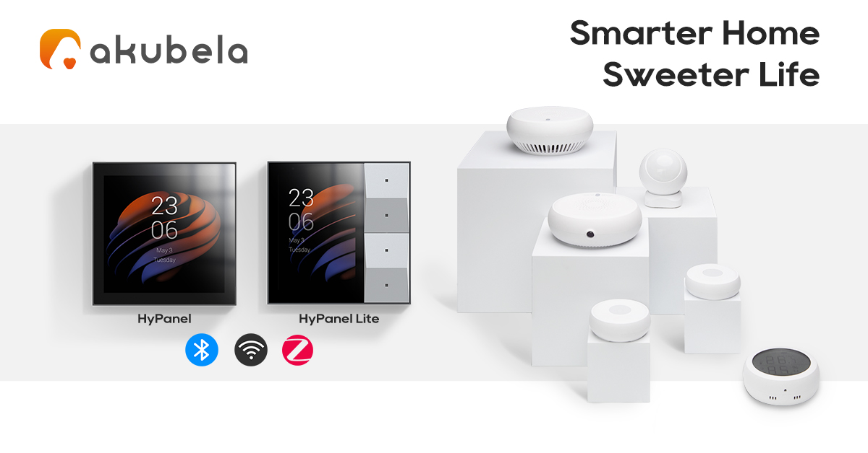
Do not miss out on any opportunity to know about Akuvox smart intercom and the brand new akubela smart home! Come to GITEX GLOBAL 2022 and try out the future-proof intercom and control panels at Z2-A1, Zabeel Hall-2, Dubai World Trade Centre. Get ready to be amazed by the smart technology!

Learn more about the exhibition at GITEX GLOBAL | 10-14 Oct | Enter the Next Digital Universe | Dubai

